Ansible Question2







Created Defaults/main.yml

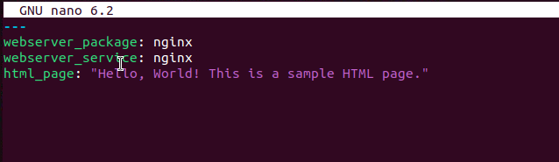

Created roles/tasks/main.yml file

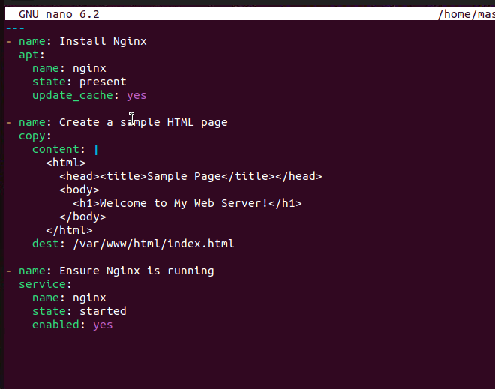

Created Handlers/main.yml file

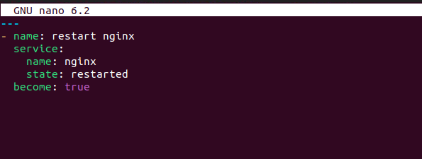



Created inventory.ini file

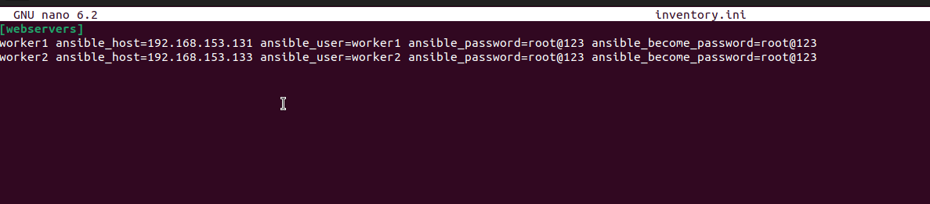



Created webserver_setup.yml playbook

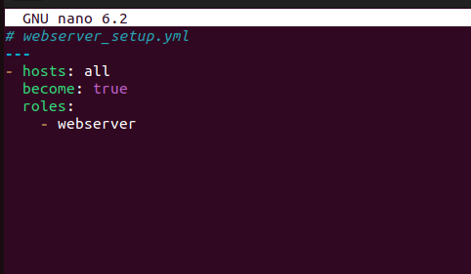

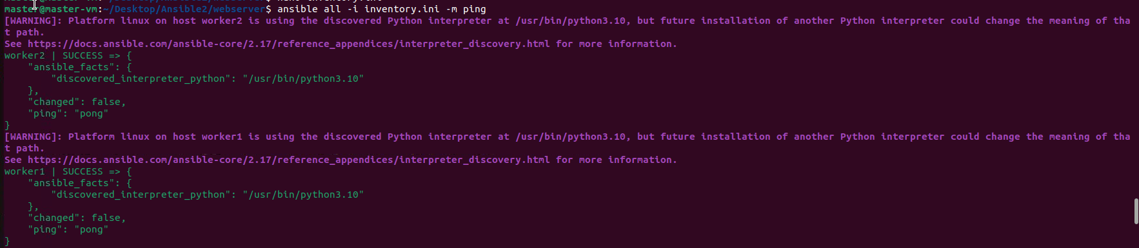

output

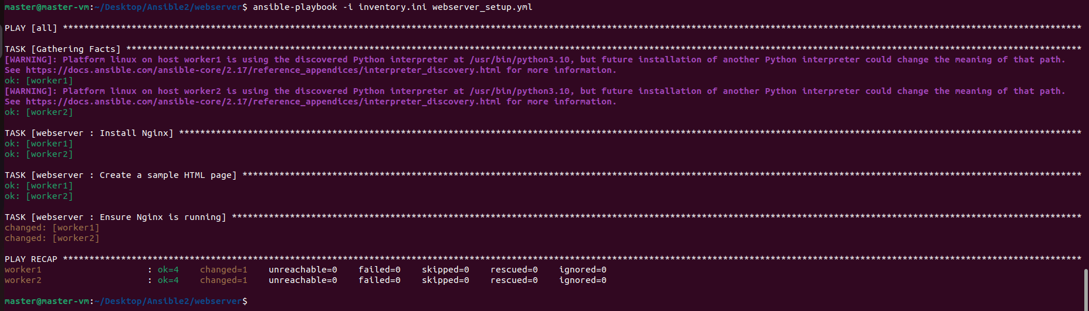

Worker 1 output

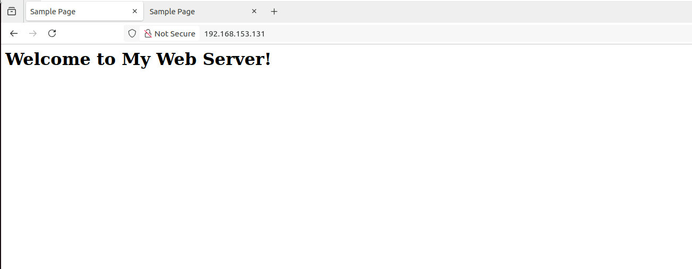

Worker2 output

